# Firmware update and diagnostics of the MSS Nav Module

Contents

Firmware update and diagnostics of the MSS Nav Module 1

Summary: 2

Enumeration and Reflashing the MSS nav module. 2

Create virtual ports and enumerate the navigation module 3

Create virtual ports and refresh firmware on the navigation module 5

Diagnostics 9

Verify navigation module connection 9

Verify UDP streams from the navigation module 10

Integratation into Greensea flight software 12

## Summary:

The MSS nav module provides ROV heading, pitch, roll, and pressure (depth) data.

There are 2 transport mechanisms TCP and UDP streams. UDP allows for lower bandwidth and a less complex protocol, however is only available with firmware versions 1.2.0 and higher.

This document describes reflashing the firmware and some simple diagnostics.

## Enumeration and Reflashing the MSS nav module.

The navigation module is connected to the ROV via the comms hub and uses tcp/ip as it’s primary communication channel.

Since it is connected directly to the comms hub reflashing the firmware requires creation of a virtual serial port through the comms hub.

On the MSS Defender the navigation module is connected to connector #2.

The following steps illustrate creating a virtual port, verifying that the navigation module is there, and reflashing the firmware.

### Create virtual ports and enumerate the navigation module

This will test the communications through the comms hub and verify that the navigation module is connected.

This can be used as a basic diagnostic that the communication channels to the nav module are working.

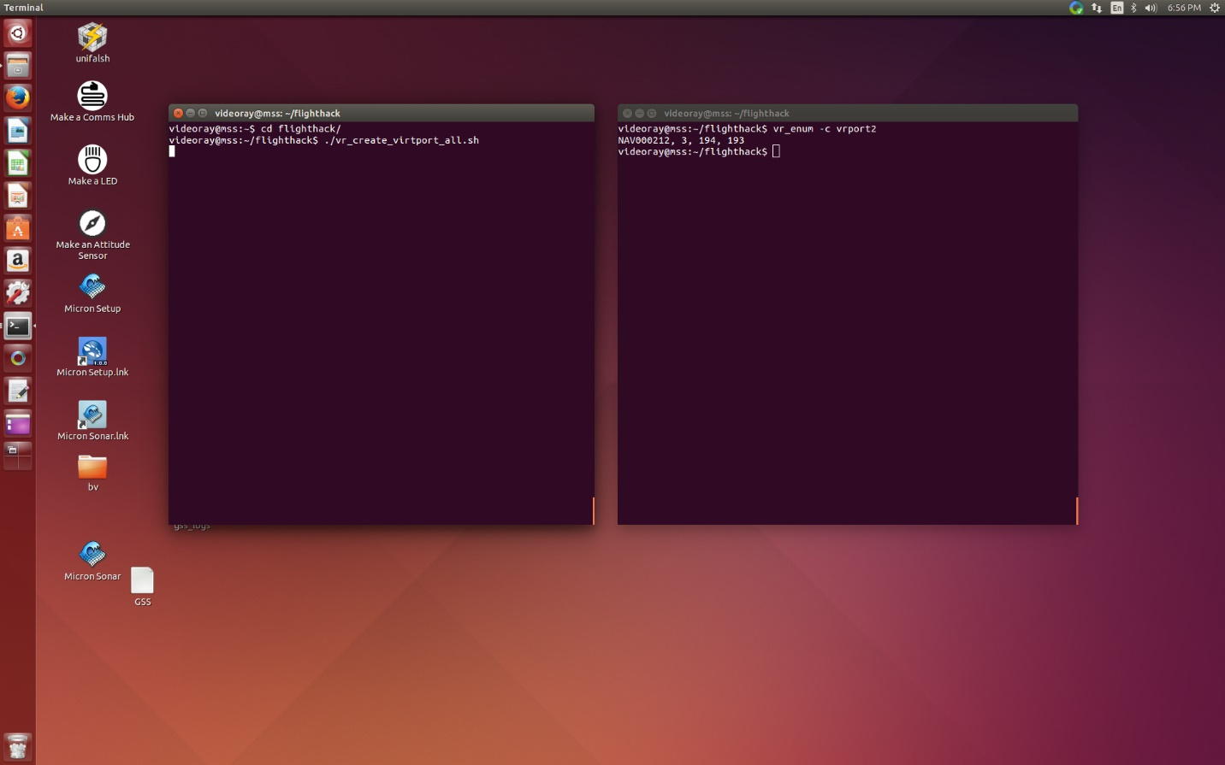

Figure 1 enumeration of nav module

Open two terminals (icon on the left launchbar 5th from the bottom).

In one terminal:

1. ***cd flighthack*** 
   1. This changes the directory into the flighthack directoy
2. ***./vr_create_virtport_all.sh*** 
   1. This creates all the virtual serial ports to the comms hub

In the second terminal:

1. ***vr_enum -c ./vrport2***
   1. This will ennumerate all the devices connected to that connector on the comms hub
      1. The navigation module should appear

### Create virtual ports and refresh firmware on the navigation module

This will update the firmware on the navifation module.

It is possible to just continue from the steps above, but the following instructiosn assume starting from a clean restart.

In one terminal:

1. ***cd flighthack*** 
   1. This changes the directory into the flighthack directoy
2. ***./vr_create_virtport_all.sh*** 
   1. This creates all the virtual serial ports to the comms hub

In the second terminal:

1. ***vr_enum -c ./vrport2***
   1. This will ennumerate all the devices connected to that connector on the comms hub
      1. The navigation module should appear
2. ***vr_refresh -c ./vrport2 --block_size 16384 ~/firmware/attitude_sensor-1.2.0.hex***
   1. This will update the firmware on the navigation module connected to connector 2 on the comms hub.
   2. The ROV should be power cycled after the fimrware had been downloaded.

The images below illustrate the process.

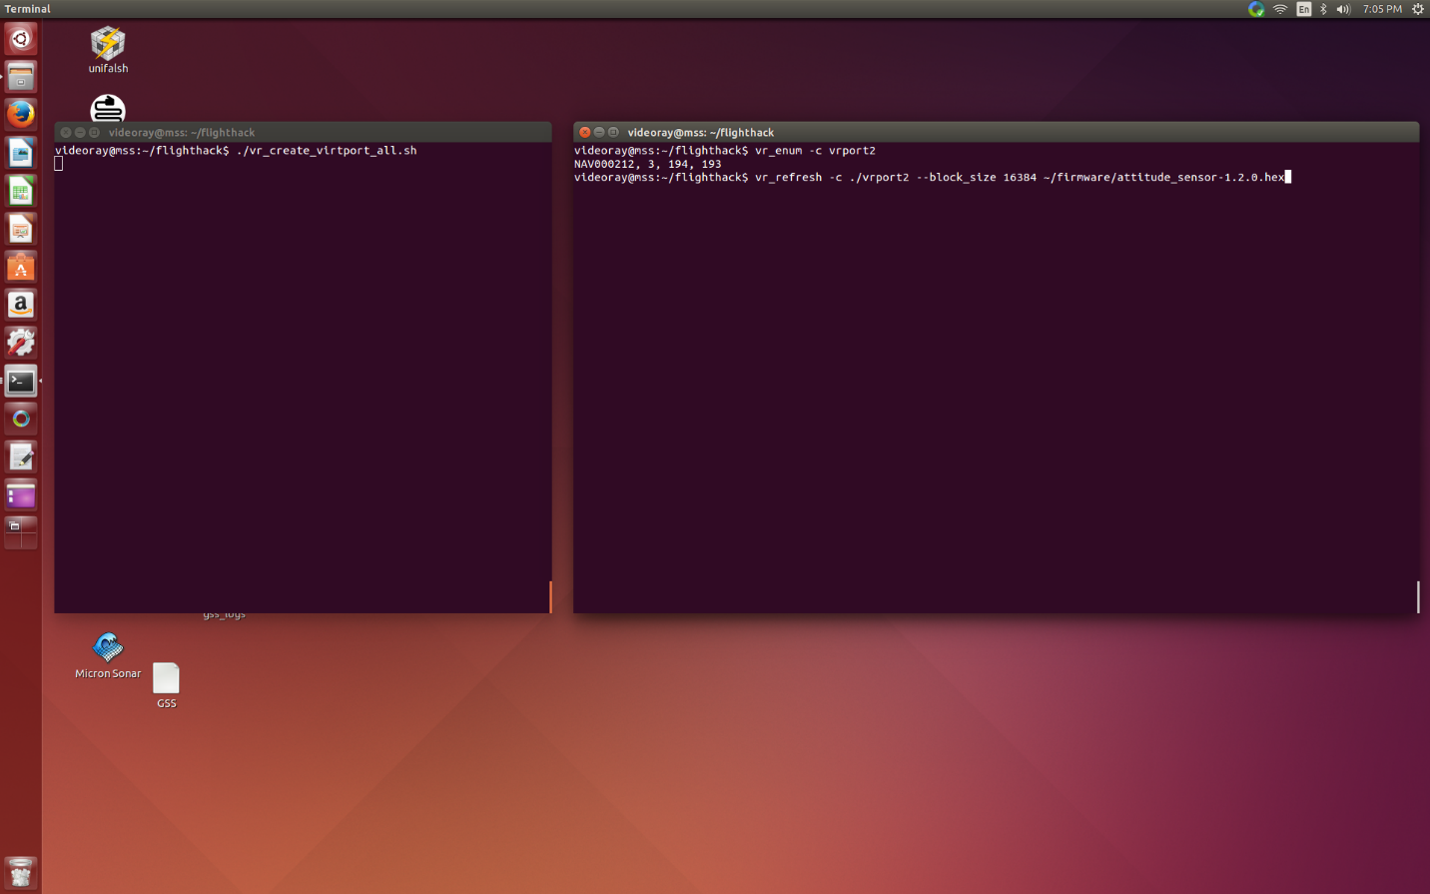

Figure 2 Ennumeration and entering of the refresh command

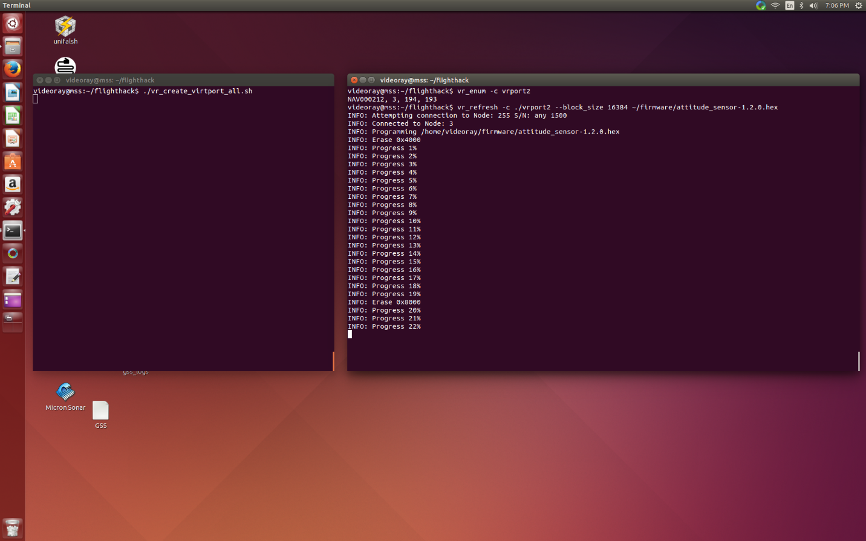

Figure 3 Firmware refresh in progress

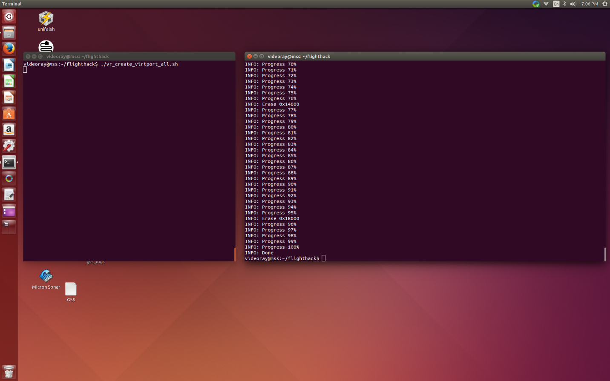

Figure 4 Firmware update complete

## Diagnostics

There a few simple diagnostics that can be performed to verify the MSS nav module is operating correctly

### Verify navigation module connection

The navigation module IP Address is set to 192.168.1.65 by default.

Pinging the navigation module should generate a response. This will test the network connection (Note the nav module may still be plugged into the wrong connector and the RS485 interface may be non functionsal).

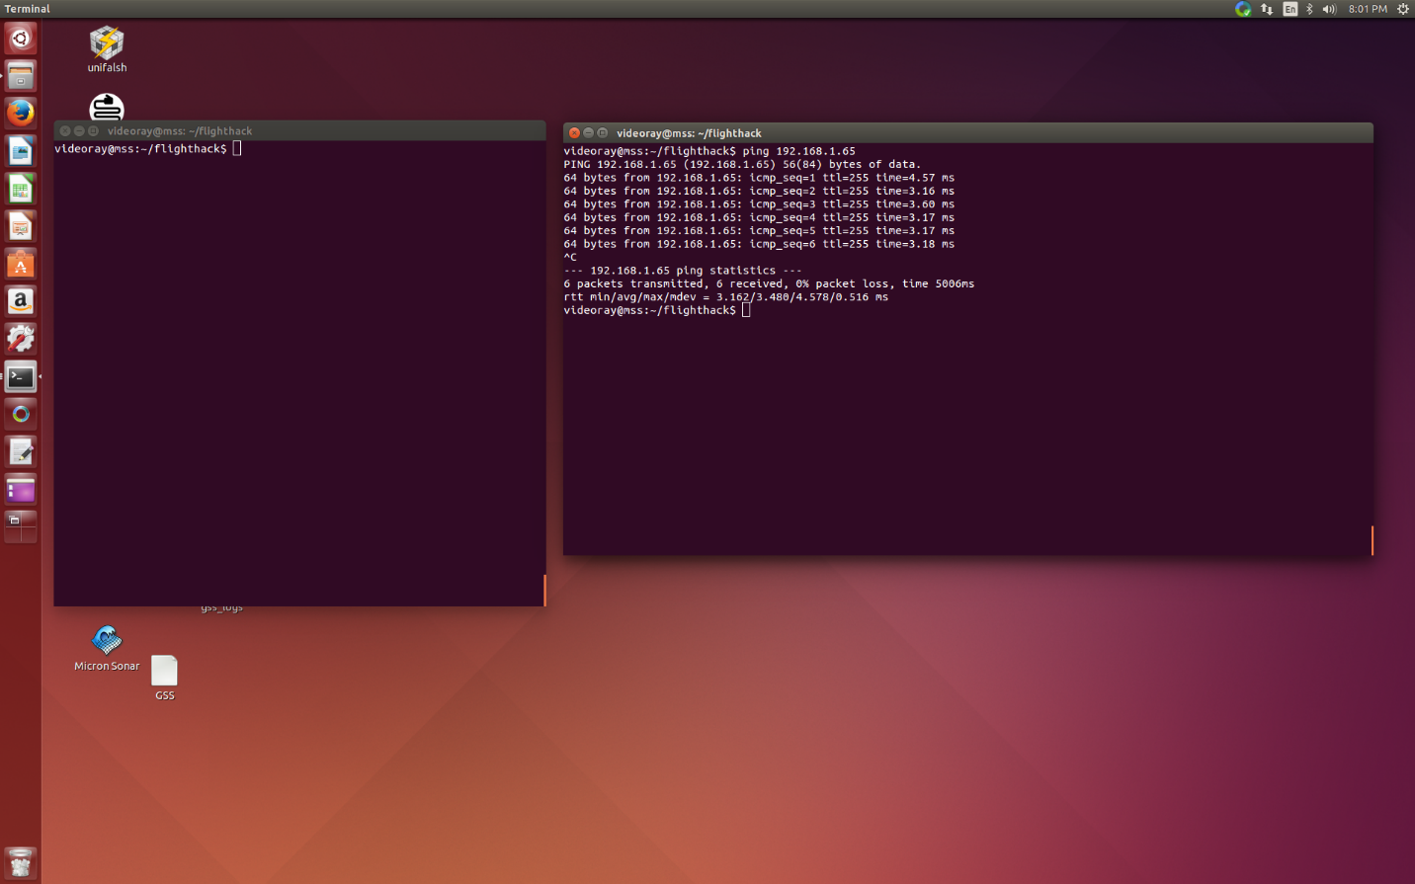

Figure 5 Ping the nav module

### Verify UDP streams from the navigation module

The navigation module transmits 2 data streams over UDP (optional TCP) to the host computer.

One stream is pressure data from the depth sensor

One stream is heading/pitch/roll from the ahrs.

Both streams are human readable.

A socat command will stream the data to a console and provides the simplest diagnostic of functionality.

#### Examine the AHRS data

The ahrs senses heading/pitch/role. This is streamed to port 8444 by default.

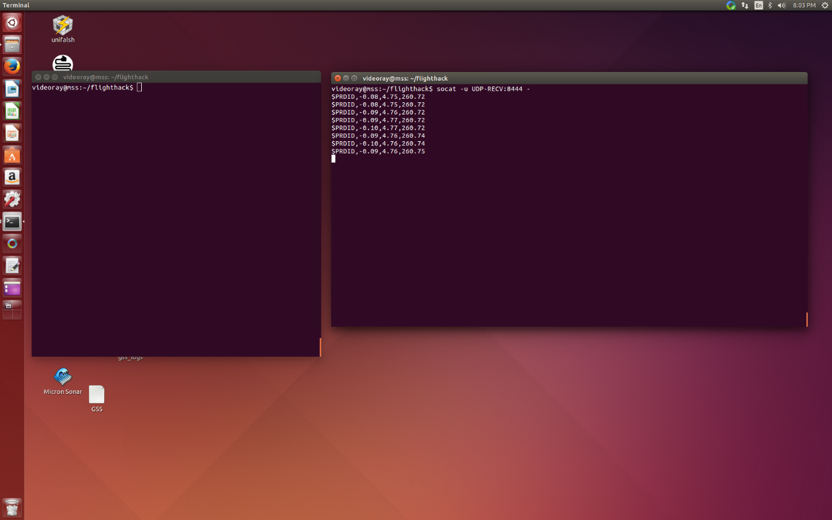

Figure 6 Verify AHRS UDP stream

1. ***socat – u UDP-RECV:8444 –***
   1. This will open the UDP port and show the streamed data.

#### Examine the Pressure / depth data

The depth sensor senses pressure and temperature This is streamed to port 8445 by default.

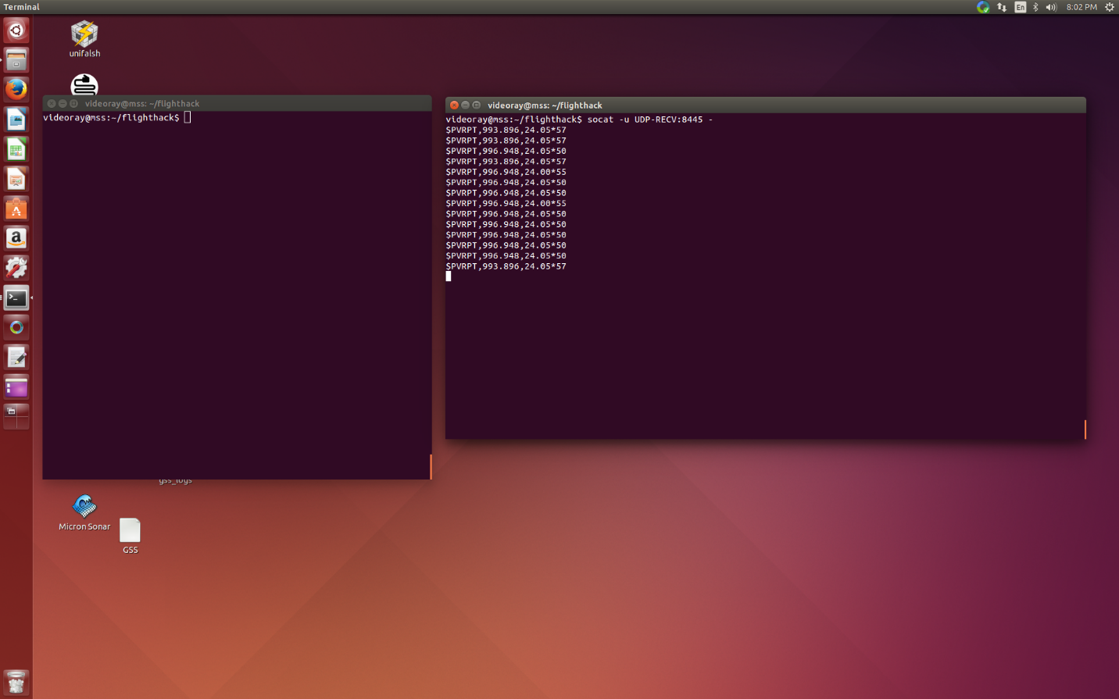

Figure 7 Verify UDP pressure / depth data

1. ***socat – u UDP-RECV:8445 –***
   1. This will open the UDP port and show the streamed data.

## Integratation into Greensea flight software

In order for the pose data (heading, pitch, roll) and depth to show up in the greensea user interface, the process_server_config.yml file must be correct.

This file is in the ~/gss_configs subdirectory (Note ~ is the users home directory, so this is equivalent to /home/videoray/gss_configs)

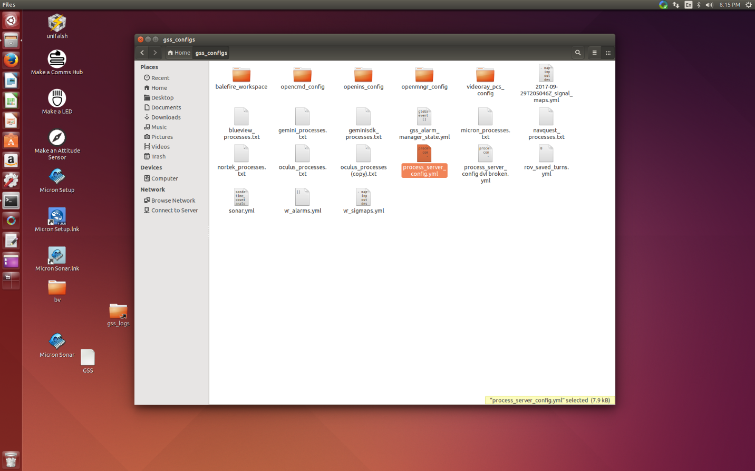

Figure 8 Location of process_server_config,yml in a file explorer

The file must point the proper processes to the proper UDP channel.

This file can be viewed in gedit. The figure below illustrates the proper settings for the relevant configuration fields.

CAUTION it is possible to render the system inoperable by incorrectly editing the process_server_config.yml file.

Insure that the relevant sections are corrected (see figure below.)

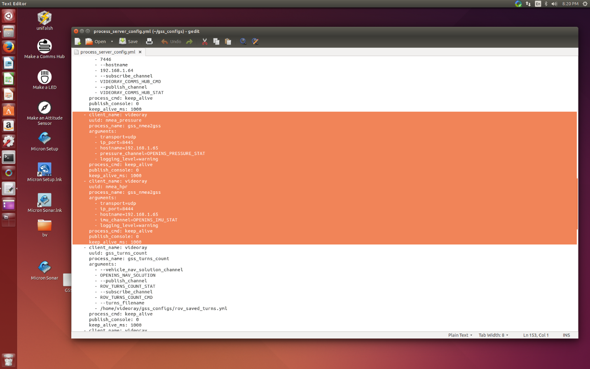

Figure 9 process_server_config.yml with AHRS sections highlighted